MATRICES INVESTIGATION

PART A – Triangle Matrices

1. Addition of two consecutive triangle matrices

Examples 1 mark
✓
✓
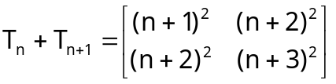 3 marks
✓

2. Determinant of triangle matrix

Examples 1 mark
✓
Det(T_{n}) = -t_{n+1} 2 marks
✓

3. Squaring of triangle matrix

Examples 1 mark
✓
✓
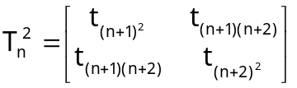 3 marks
✓

4. Product of two consecutive triangle matrices

Examples 1 mark
✓
✓
✓
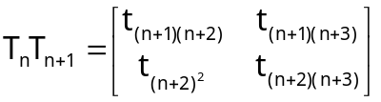 3 marks
PART B – Fibonacci Matrices

1. Addition of two consecutive Fibonacci matrices

Examples 1 mark

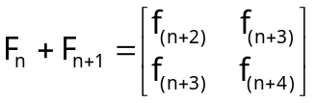 (4 x ½ mark)
= F_{n+2} or 2 marks

2. Product of two consecutive Fibonacci matrices

Examples 1 mark

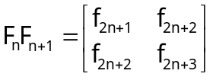 (4 x ½ mark)
= F_{2n+1} or 2 marks

3. Product of two non-consecutive Fibonacci matrices

Examples 1 mark

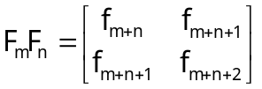 (4 x ½ mark)
= F_{m+n} or 2 marks

4. Determinant of the Fibonacci matrix

Examples 1 mark

Det(F_{n}) = (-1)^{n} or equivalent statement(s) 2 marks
(1 would only get 1 mark)

5. Solution to simultaneous equations

f_{n}x + f_{n+1}y = f_{m}
f_{n+1}x + f_{n+2}y = f_{m+1}

such that m ≥ n + 1

x = f_{m-n} 2 marks
y = f_{m-n+1} 2 marks

